# CS 255 System Design Document Template

This template lays out all the different sections that you need to complete for Project Two. Each section has guidance to prompt your thinking. You will need to continually reference the interview transcript as you work to make sure that you are addressing your client’s needs. There is no required length for the final document. Instead the goal is to complete each section based on what your client’s needs are. Remove this note when you are finished, and replace all bracketed text with the relevant information.

## UML Diagrams

### UML Use Case Diagram

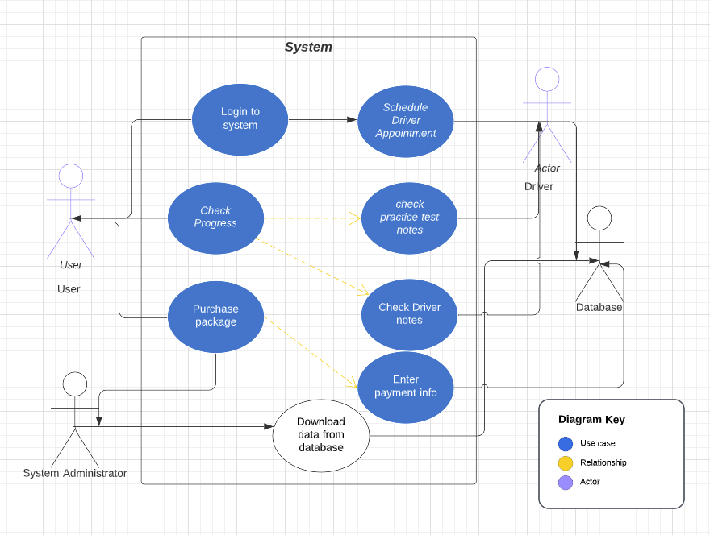

### UML Activity Diagrams

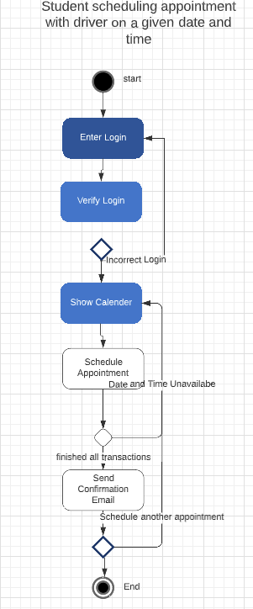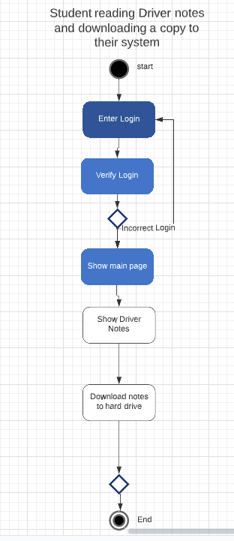

### UML Sequence Diagram

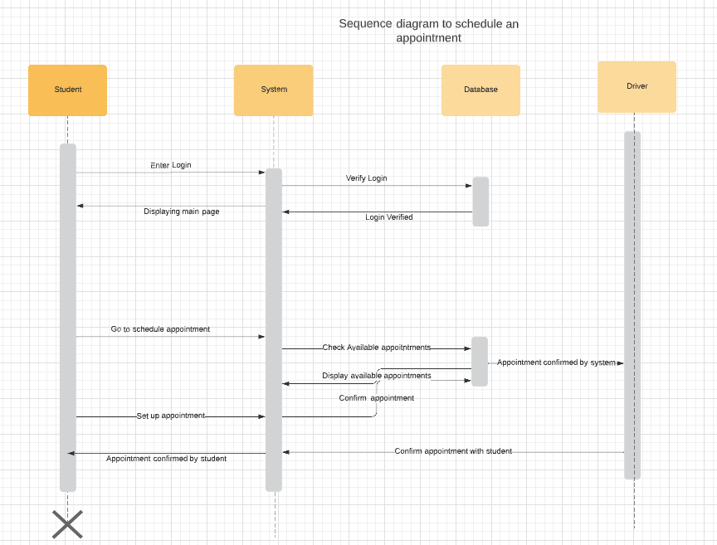

### UML Class Diagram

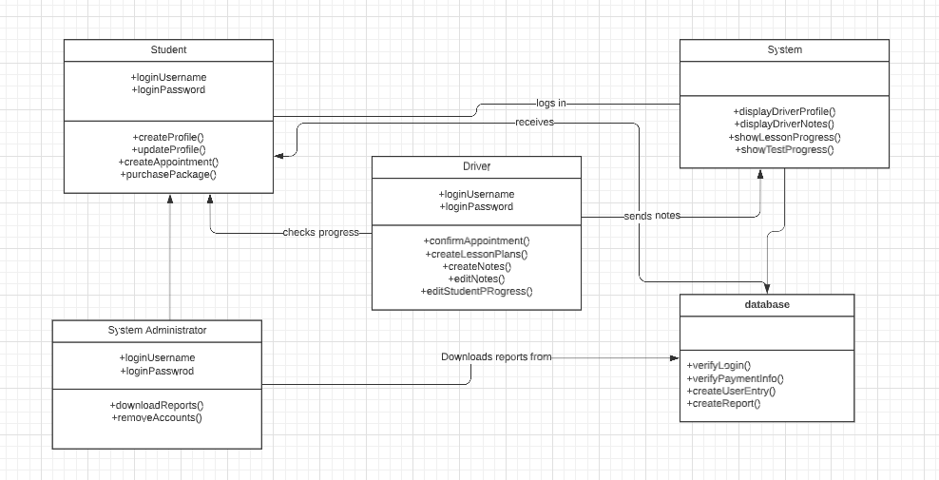

## Technical Requirements

*To start with the hardware aspect, this system runs on the web, so a web server will be needed to run this system. Even with the request of the cloud system, that system must have a means to operate as needed. The software used for this will be Linux. Linux is very lightweight when it comes to hardware aspects and is very low cost. Also, most cloud systems run using Linux so the cloud system can use as much of the resources as possible. As for the tools of this system design, the two main tools would be cloud operation tools and web development tools and software. These will accompany the ability to run the website off the cloud with ease. The overall infrastructure can be added onto two different racks: One rack will have a firewall, router and switch for internet security and connections, the other rack will have two servers, one for the website itself and the other for the database. Allowing a structure like this will enable the website to run safely and effectively and with a 99.99% uptime.*